Fuzz Testing
Triage Procedure

Revision
Version 1
6/26/26 8:55 AM

Author
Charles Wilson

Abstract
This document describes the procedure used to perform the triage activity described in the AVCDL ^{[1]} secondary document Fuzz Testing Report ^{[2]}.

Group / Owner
Security / Security Architect

Motivation
This document is motivated by the need to have runtime-specific, cybersecurity-related feedback in the development of software for use within safety-critical, cyber-physical systems.
Note: Within the context of this document, the terms security and cybersecurity are used interchangeably. It is presumed that the term security is being used in reference to cybersecurity and not physical security.

License
This work was created by Torc Robotics and is licensed under the Creative Commons Attribution-Share Alike (CC BY-SA-4.0) License.
https://creativecommons.org/licenses/by/4.0/legalcode

Audience
The audience of this document is the cybersecurity practitioner who will be conducting cybersecurity-specific fuzz testing.

Completeness of Output
Since fuzz testing is an as-is analysis, it is critical to ensure that the information gathered is as accurate and complete as possible. As with any cybersecurity assessment, it is not the place of the fuzz testing SME to make assumptions on the part of engineering. All information should be sourced from and confirmed by the owner of the element under consideration.

Disposition of Output
Once completed, the generated output should be managed in the organization’s document management system (DMS) as a document of record.

Entry Criteria
This document assumes that the reader understands the purpose of cybersecurity-specific fuzz testing. Further, that the reader has read and understood the following:
- Fuzz Testing Report
- Fuzz Testing – Establish Settings Procedure ^{[3]}
- Fuzz Testing – Create Test Procedure ^{[4]}
- Fuzz Testing – Perform Testing Procedure ^{[5]}
- Report Generation ^{[9]}

Prerequisites – Development SME

Qualifications
It is required that the development SME is both a qualified and trained development SME with expertise in the element under consideration.
Note: The specific qualifications and training of development SMEs necessary to assert expertise in providing accurate information regarding the element under consideration is outside the scope of this document.
Note: The development group is responsible for determining and making available the appropriate SME for the triage of the element under consideration.

Knowledge
It is required that the development SME have expertise in the element under consideration.

Prerequisites – Fuzz Testing SME

Qualifications
It is required that the fuzz testing SME is both a qualified and trained security architect (shown above on title page as Owner) as defined by the NIST NCWF role SP-ARC-002 and detailed in the NCWF Roles - Security Architect section of the AVCDL Background Material elaboration document ^{[8]}.

Knowledge
It is required that the fuzz testing SME understands the purpose of cybersecurity-specific fuzz testing.

Background Information
It is required that the fuzz testing SME has read and understands the following documents:
- Fuzz Testing Report
- Fuzz Testing – Establish Settings Procedure
- Fuzz Testing – Create Test Procedure
- Fuzz Testing – Perform Testing Procedure
- Report Generation
Additionally, that the fuzz testing SME has taken the trainings relevant to this activity.

Prerequisites – Input Materials
It is required that the fuzz testing SME acquire all relevant documentation related to the tool under consideration necessary to complete the procedure.
It is required that the development group provide all relevant documentation related to the element under consideration necessary to complete the procedure.

Triage Activity
The workflow diagram for the triage activity of the Fuzz Testing process is shown below.
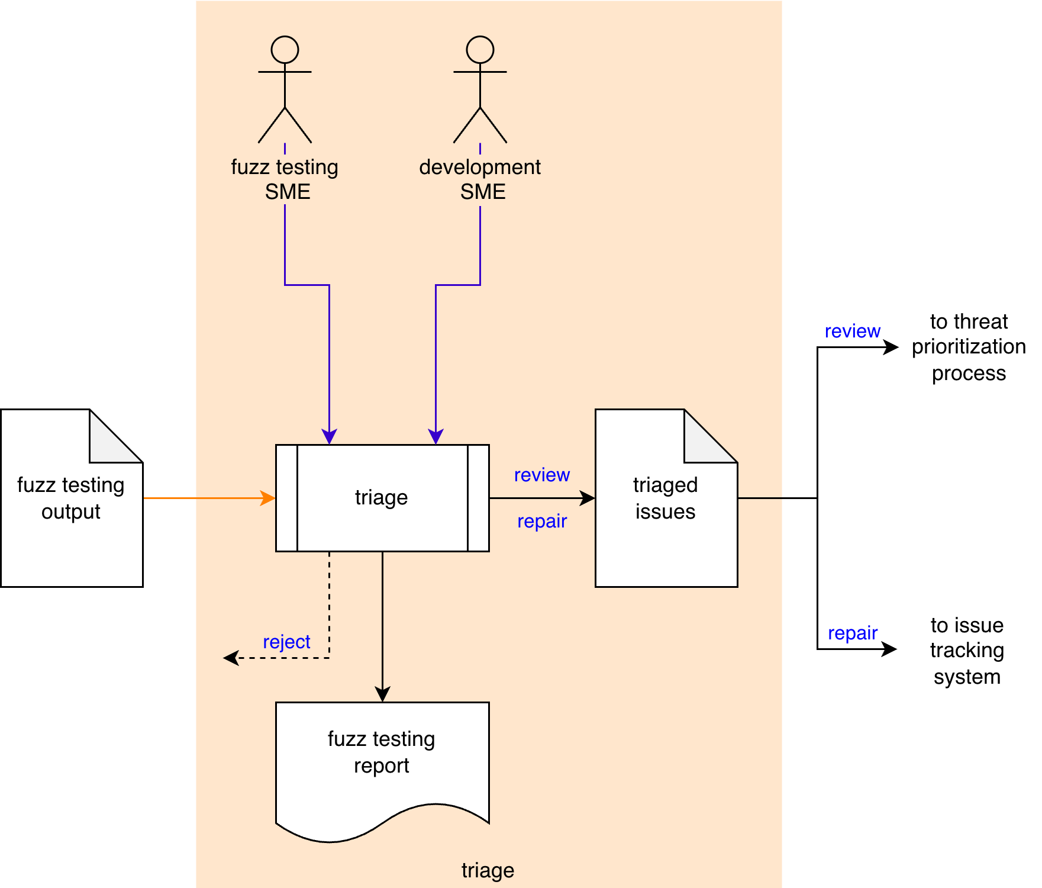
The Fuzz Testing SME and the Development SME triage the Fuzz Testing Output to identify any anomalous behavior needing review or repair. Triaged Issues are sent to the threat prioritization process ^{[7]}. False positives are rejected and require that the Element Fuzz Test created during the create test activity be updated to address the issue. A Fuzz Testing Report will be generated.
Note: Depending on the element scope and nature of the identified issue, issues may be entered directly into the issue tracking system.
Note: The recommended form of the Triaged Issues artifact is JSON-encoded Static Analysis Results Interchange Format (SARIF). This document assumes SARIF version 2.1.0 ^{[6]} or later.

Methodology
The purpose of triage is first and foremost to eliminate those issues which are false positives. A secondary goal is to identify “must fix” issues. What remains is put into the threat prioritization process.
There are three options when dispositioning an issue. These are:

Reject
This disposition should be assigned when the issue is determined to be a false positive. The Fuzz Testing SME should update the test and verify that the issue is no longer flagged.

Review
This disposition should be assigned when the issue is determined to require additional review via the threat prioritization process.

Repair
This disposition should be assigned when the issue is clearly one which requires mitigation. These issues should be directly entered into the issue tracking system. If the issue comes from a test which resulted in an expected program termination, it probably fits into this category.

Fuzz Testing Triage Template
The triage activity may be documented using the AVCDL fuzz testing triage template Microsoft Excel workbook ^{[4]}.
Note: Other forms of documentation are permissible so long as they provide the information laid out in this document.
There are five sheets in the workbook. They are:
- Cover sheet
- Revision history
- Reference documents
- Triage determination
- Legend
These will be addressed in turn.

Duplication of Rows in the Various Sheets
When there is the need to add rows to the various sheets of the workbook, be sure to duplicate an existing row. This is because validation checks are attached to some of the cells which also enables the use of dropdown lists.

Cover Sheet
The cover sheet of the workbook is shown below:
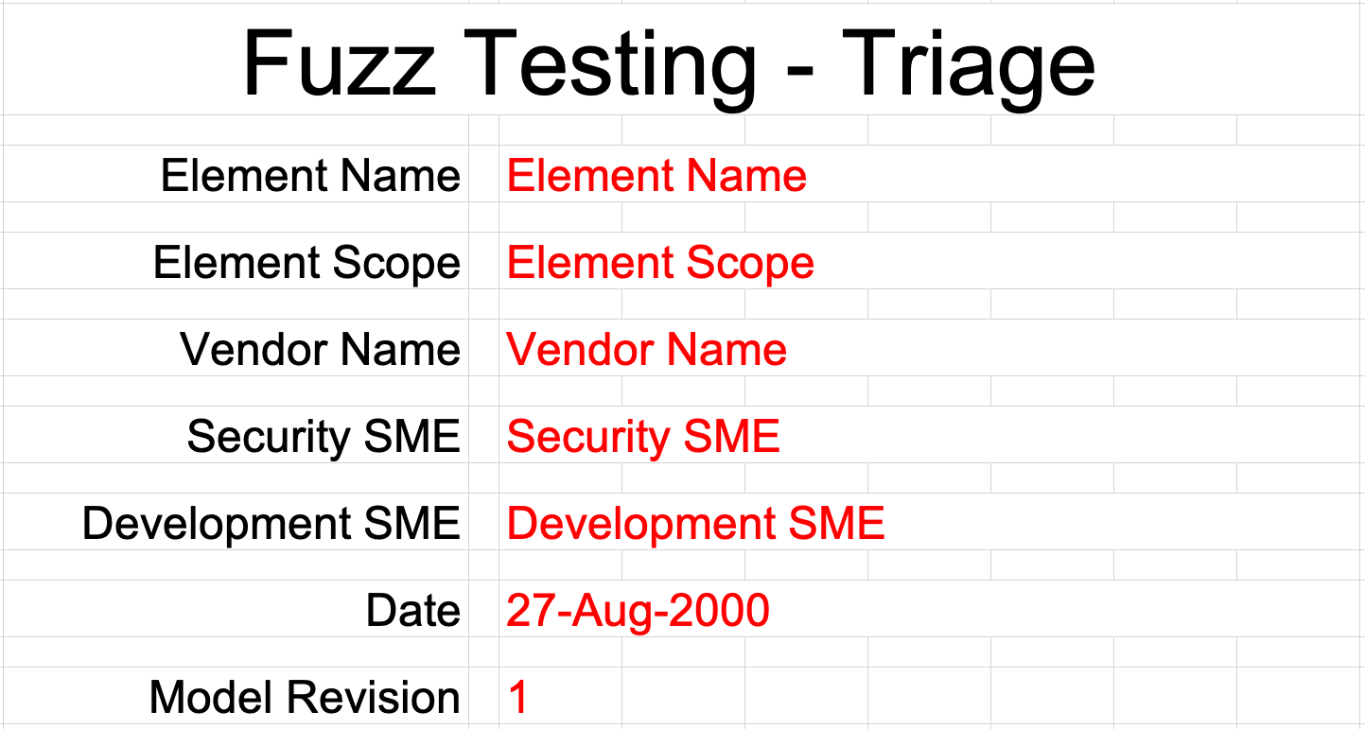
Fields to be completed are shown in red.

Element Name
The element name is the element whose fuzz testing issues are being triaged.

Element Scope
The scope of the element is left to the discretion of the customer. Examples of element scopes include system, sub-system, component, component software (non-OS), and component OS.
Note: In this context, the customer refers to the entity requiring the activity.

Vendor Name
This is the name of the vendor responsible for the element under consideration.

Security SME
This is the fuzz testing subject matter expert triaging the fuzz testing output.

Development SME
This is the development subject matter expert providing information about the element.

Date
This is the date when the element’s fuzz testing triage was created or updated. The date should be updated whenever the document is updated.

Revision
This is the revision number of the document. The revision number is a monotonic and increasing integer, starting at 1. It should be incremented every time the document is updated.

Revision History
The revision history sheet of the workbook is shown below:
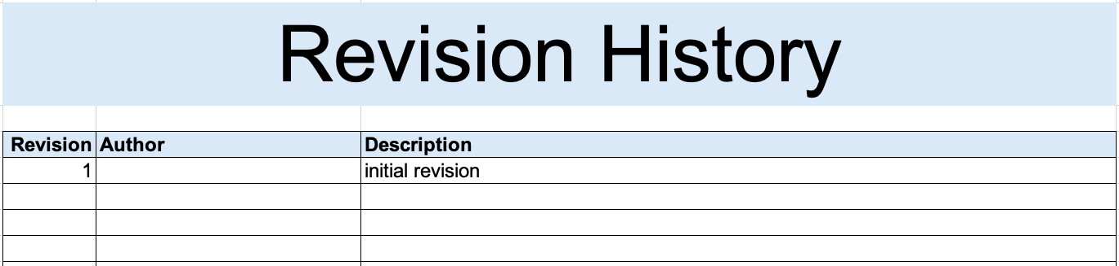

Revision
The revision corresponds to that listed on the cover sheet.

Author
The author corresponds to the security SME listed on the cover sheet.

Description
This is a brief description of changes made to the fuzz testing triage since it was last updated.

Reference Documents
Note: These references are those necessary for the creation of the element’s fuzz testing output triage.
Note: Reference to the element’s fuzz testing output should be included.
The references sheet of the workbook is shown below:
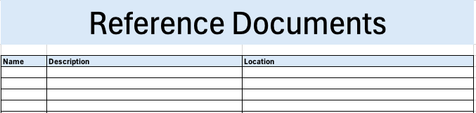

Name
This is the name of the document being referenced.

Description
This is a brief description of the document being referenced.

Location
This is the location of the document being referenced. It may be a physical location or a URL.

Triage Determination
The triage determination sheet of the workbook is shown below:
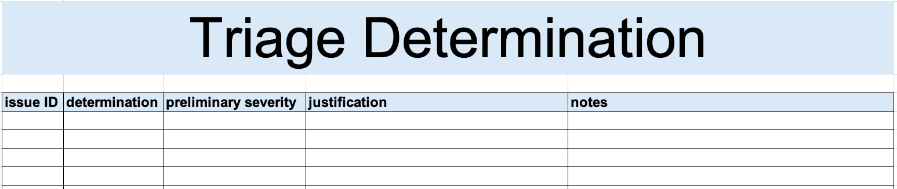

Issue ID
This is the unique element fuzz testing issue ID.

Determination
This is the determination of the issue’s triage. It may be one of the following:
- reject
- review
- repair
Note: The meanings of these were covered earlier in this document.

Preliminary Severity (optional)
If the determination is that the issue is valid, a preliminary severity (rank / likelihood) may be provided.
Note: The preliminary severity value set is not provided as it is highly specific to the organizational and domain. A discussion of quantized rank values can be found in the Ranked / Risked Threat Report ^{[10]} ACVDL secondary document.

Justification
This is the justification for the selected determination.
Note: If the determination is that the issue is reject, a justification is required.

Notes
This is a general notes field.

Legend
The legend sheet of the workbook is shown below:
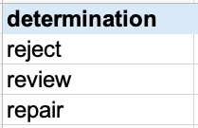
The legend sheet information is used to make the completion of the document easier by providing dropdown lists for common values. It also ensures that spelling errors do not creep into the generated material.
Note: The legend sheet should not be edited. If an unlisted value is required, the template should be separately revised.

Fuzz Testing Report
The Fuzz Testing Report is the human-readable record of the activity. It is intended to be a standalone document for audit purposes. It’s preferred embodiment for storage in the DMS is PDF. The content of the report is covered in the Fuzz Testing Report AVCDL secondary document.
Note: If possible, it is recommended that the fuzz testing report be generated programmatically. Creating the report from the JSON-encoded SARIF for the Identified Issues file makes this process much easier.
Note: Although all issues contained in the Fuzz Testing Output may be included in the report, it is recommended to restrict the report to only those items which are not rejected. Additionally, it is recommended that the items chosen for review and repair be in separate sections.

Exit Criteria
This procedure is considered complete once the Fuzz Testing Report has been entered into the organization’s DMS as a document of record.
Note: The processes and procedures for entering documents into the DMS, or the updating thereof, are outside the scope of this document.

References
- AVCDL (AVCDL primary document)
- Fuzz Testing Report (AVCDL secondary document)
- Fuzz Testing – Establish Settings Procedure (AVCDL tertiary document)
- Fuzz Testing – Create Test Procedure (AVCDL tertiary document)
- Fuzz Testing – Perform Testing Procedure (AVCDL tertiary document)
- Static Analysis Results Interchange Format (SARIF) Version 2.1.0
https://docs.oasis-open.org/sarif/sarif/v2.1.0/os/sarif-v2.1.0-os.pdf
- Threat Prioritization Plan (AVCDL secondary document)
- AVCDL Background Material (AVCDL elaboration document)
- Report Generation (AVCDL elaboration document)

